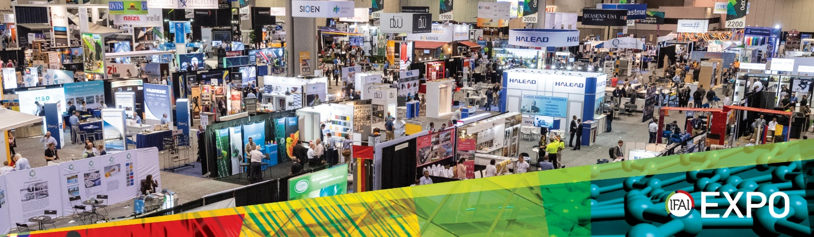
IFAI Expo 2021 email template
Join us at IFAI Expo 2021 for FREE!
On behalf of our entire team at <YOUR COMPANY NAME>, we want to invite you to join us at IFAI Expo 2021 in Nashville, TN, Nov 2-4, 2021. We are excited to be exhibiting at the show and to showcase all of our latest products and services.
You can use our code <YOUR EXHIBITOR DISCOUNT CODE HERE> when registering to get a FREE Show Floor Only registration or you can receive 10% off of a Full Registration.
Register Now button/CTA (link to IFAIExpo.com/Register)
This year, IFAI Expo will be co-located with Messe Stuttgart’s new U.S.-based show Sun Shading Expo North America. Learn more about IFAI Expo 2021 at IFAIExpo.com and we hope to see you at the show!
If you have any questions, please contact us at <YOUR COMPANY CONTACT INFO HERE>
See you in Nashville!
<YOUR COMPANY SALUTATION>

