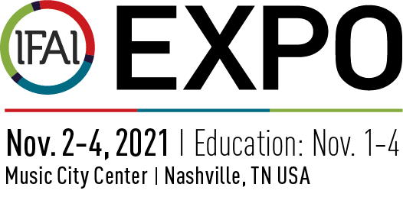

Exhibitor Press Release Template

FOR ADDITIONAL INFORMATION FOR IMMEDIATE RELEASE
Contact: [YOUR NAME] [RELEASE DATE]
Phone: [YOUR PHONE]
Email: [YOUR CONTACT EMAIL]
Twitter: [HASHTAG]

[YOUR COMPANY] TO EXHIBIT AT IFAI EXPO 2021 IN NASHVILLE, TN USA

[COMPANY] to exhibit at the leading show for sourcing, education and networking across the textiles industry.

[YOUR CITY] — IFAI Expo 2021 is known as the flagship show for textile industry professionals to buy, sell, network and learn. Each year thousands of decision makers attend to source new products and find solutions to move their business forward. [COMPANY] has chosen to exhibit and display their new [PRODUCTS/EQUIPMENT/SERVICES] at IFAI Expo 2021 taking place Nov. 1-4, 2021 at the Music City Center in Nashville, TN USA.
IFAI Expo 2021 starts on Nov. 1 with the Advanced Textiles Conference and opens the show floor on Nov. 2 which runs through Nov. 4. The show will feature live demonstrations on the show floor, education sessions by market, networking events and keynote speaker presentations.
“IFAI Expo 2021 provides the perfect environment for us to display our [PRODUCTS/EQUIPMENT/SERVICES LAUNCH OR LIVE DEMONSTRATIONS],” said [YOUR COMPANY SPOKESPERSON].

[YOUR COMPANY DETAILS HERE]

For the first time this year, IFAI Expo will co-located with Messe Stuttgart’s new U.S. show Sun Shading Expo North America. This show focuses on internal sun protection similar to R+T events worldwide. Co-locating provides unprecedented value in the opportunity to connect with customers, suppliers, end-product manufacturers and industry counterparts.
Registration for IFAI Expo 2021 is now open at IFAIExpo.com/Register.

###

About [YOUR COMPANY: Enter your copy and contact information here.]

About Sun Shading Expo North America
Sun Shading Expo North America will be a meeting point, an industry barometer, and an innovation platform for the interior and exterior sun protection industries. This will be an excellent platform for companies from all over the world to establish new cooperation’s.

About IFAI Expo
IFAI Expo is North America’s largest specialty, industrial and advanced textiles event, hosting more than 300 exhibiting companies annually for an average 4,412 verified participants from 60+ countries. IFAI Expo is produced by Industrial Fabrics Association International (IFAI).

